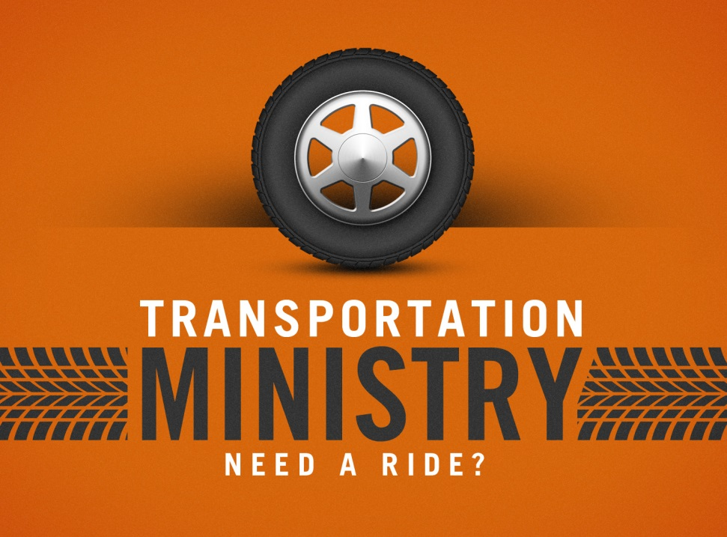
IMPACT KIDZ NEW MINISTRY!
Dear Parents,
Are you too tired to get out of bed to take your child to Sunday school? Or do you attend second service and your child comes with you? Does your child attend World Changers on Wednesday night? Well, I have a solution for you! IMPACT KIDZ is offering a free service to help your child make it to church on Sunday morning and Wednesday evenings. Ol’ Henry, the church bus, is available to pick your child up at your residence and transport them safely to the church and will bring your children back home. I would love to see our church families take advantage of this ministry as they continue to be formed into what God has created them to be. If you are interested in taking advantage of the ministry, please fill out the portion below and return it to me.
Pastor Noah Farmer
pastornoahfarmer@eastviewwesleyan.com
- - - - - - - - - - - - -
Child’s Name: _____________________________________________________
Parent’s Name: ____________________________________________________
Address:____________________________________ City:_________________
Phone: __________________________
Transportation needed: Wednesday (7pm) Sunday School (9:30am) *You will be notified of pick-up and drop-off times

